Simply Impressive Thesis Title Line 1
Simply Impressive Thesis Title Line 2

Text Type: Times New Roman
Text Size: 26



Width: 1.72
Height: 1.72

By

Student Name1
Student Name2

Just student names (NO ROLL NO)
Text Type: Time New Roman
Text Size: 18
Just student names (NO ROLL NO)
Text Type: Time New Roman
Text Size: 18

Recent Month and Year

Department of Information Technology

University of Haripur

June, 2024

Title of Thesis

Text Type: Times New Roman
Text Size: 26

Text Type: Times New Roman
Text Size: 18

By

Student Name1, Student Name1
F20-2387, F20-2388

Supervised by

Dr. X

Department of Information Technology

University of Haripur

June 2024

Title of Thesis
Text Type: Times New Roman
Text Size: 26

Text Type: Times New Roman
Text Size: 18

By

Student Name1, Student Name2

Text Type: Times New Roman
Text Size: 14

A Dissertation Submitted in Partial Fulfilment for the Degree of

BACHELORS

IN

COMPUTER SCIENCE

Text Type: Times New Roman
Text Size: 18

Department of Information Technology

University of Haripur

June 2024

Title of Thesis
Text Type: Times New Roman
Text Size: 26
Text Type: Times New Roman
Text Size: 18
By

Student Name1, Student Name2

Text Type: Times New Roman
Text Size: 12
CERTIFICATE

A THESIS SUBMITTED IN THE PARTIAL FULFILMENT OF THE
REQUIRMENTS FOR THE DEGREE OF BACHELORS

IN COMPUTER SCIENCE

We accept this dissertation as conforming to the required standards

Supervisor Name

Project Supervisor

External Examiner

Dr. Shabih-ul-Hassan

Final Year Project
Coordinator

Dr. Ikram-ud-Din

Chairman

Text Type: Times New Roman
Text Size: 18

Department of Information Technology

University of Haripur

June 2024
Line1
Spaces: 3 lines with font size 25
Line2
Line3
Text Type: Times New Roman
Text Size: 26
Declaration
Line1
Spaces: 2 lines with font size 25
Line2
I hereby declare that this dissertation is neither as a whole or part thereof has been copied out from any source. If any part of this thesis is proved to be copied or found to be a report of some other, we shall bear the consequences. No portion of this work presented in the thesis has been submitted in support of any application from any other degree of qualification or any other university or any other institute of learning.
I further declare that this research and all the associated documents with this, reports and all records are submitted as a partial requirement of the degree of Bachelor in Computer Science. We understand and transfer copyrights for these materials to University of Haripur and we will not sale this research and documents for getting any financial gains. It is further declared that I developed this and also this thesis is entirely on the basis of our personal efforts made under the sincere guidance of the project supervisor Dr. Y. Saeed, Department of Information Technology, University of Haripur, Haripur.

Date: 24th June, 2024 Student1 Name Student2 Name

Signature Signature

Line1
Spaces: 3 lines with font size 25
Line2
Line3
Text Type: Times New Roman
Text Size: 26
Plagiarism Certificate
Line1
Spaces: 2 lines with font size 25
Line2
This thesis has been checked for Plagiarism. Turnitin report endorsed by Supervisor is attached at the end of thesis.

Date: 24th June, 2024

Student Name(s)

Student Signature

Supervisor Signature

Text Type: Times New Roman
Text Size: 16

Dedicated to

My Parents

Line1
Spaces: 3 lines with font size 25
Line2
Line3
Text Type: Times New Roman
Text Size: 26
Acknowledgements
Line1
Spaces: 2 lines with font size 25
Line2
Acknowledgement text start here. It should contain acknowledging people who facilitated the student in carrying out the project.

Line1
Spaces: 3 lines with font size 25
Line2
Line3
Text Type: Times New Roman
Text Size: 26
Abstract
Line1
Spaces: 2 lines with font size 25
Line2
Abstract text start here. It should contain what exactly the student is about to do in thesis.
Line1
Spaces: 3 lines with font size 25
Line2
Line3
Text Type: Times New Roman
Text Size: 26
Table of Contents
Line1
Spaces: 2 lines with font size 25
Line2
Declaration |  |  |  | . . . . . . . . . . . . . . . . . . . . . . . . . . . . . . . . . . . . . . . |  |  |  | i
Dedication |  |  |  | . . . . . . . . . . . . . . . . . . . . . . . . . . . . . . . . . . . . . . . |  |  |  | ii
Acknowledgements |  |  |  |  |  |  | . . . . . . . . . . . . . . . . . . . . . . . . . . . . . . . . . . . | iii
Abstract |  |  | . . . . . . . . . . . . . . . . . . . . . . . . . . . . . . . . . . . . . . . . . |  |  |  |  | iv
List of Figures |  |  |  |  |  | . . . . . . . . . . . . . . . . . . . . . . . . . . . . . . . . . . . . . . |  | v
List of Tables |  |  |  |  |  | . . . . . . . . . . . . . . . . . . . . . . . . . . . . . . . . . . . . . . |  | vi
Chapter 1 |  |  |  |  |  | Introduction . . . . . . . . . . . . . . . . . . . . . . . . . . . . . . |  | 1
1.1 |  | This is the heading of the chapter . . . . . . . . . . . . . . . . . . . . . . . . . . |  |  |  |  |  | 1
 |  | 1.1.1 |  |  | This is the sub-heading . . . . . . . . . . . . . . . . . . .  . . . . . . . . |  |  | 1
Chapter 2 |  |  |  |  |  | Related Work . . . . . . . . . . . . . . . . . . . . . . . . . . . . . . |  | 11
Chapter 3 |  |  |  |  |  | Proposed System . . . . . . . . . . . . . . . . . . . . . . . . . . . . |  | 21
3.1 | Requirement Analysis . . . . . . . . . . . . . . . . . . . . . . . . . . . . . . . . |  |  |  |  |  |  | 21
3.2 | Design . . . . . . . . . . . . . . . . . . . . . . . . . . . . . . . . . . . . . . . |  |  |  |  |  |  | 25
3.3 | Methodology . . . . . . . . . . . . . . . . . . . . . . . . . . . . . . . . . . . . |  |  |  |  |  |  | 30
Chapter 4 |  |  |  |  |  | Evaluation and Results . . . . . . . . . . . . . . . . . . . . . . . . |  | 36
4.1 | Implementation . . . . . . . . . . . . . . . . . . . . . . . . . . . . . . . . . . . |  |  |  |  |  |  | 36
4.2 | Testing . . . . . . . . . . . . . . . . . . . . . . . . . . . . . . . . . . . . . . . |  |  |  |  |  |  | 45
Chapter 5 |  |  |  |  |  | Conclusion and Future Work. . . . . . . . . . . . . . . . . . . . . |  | 50
5.1 Conclusion . . . . . . . . . . . . . . . . . . . . . . . . . . . . . . . . . . . . . |  |  |  |  |  |  |  | 50
5.2 Future Work . . . . . . . . . . . . . . . . . . . . . . . . . . . . . . . . . . . . |  |  |  |  |  |  |  | 51
Appendix |  |  |  |  |  | . . . . . . . . . . . . . . . . . . . . . . . . . . . . . . . . . . . . . . |  | 53
References |  |  |  |  |  | . . . . . . . . . . . . . . . . . . . . . . . . . . . . . . . . . . . . . . |  | 54

Line1
Line2
Line3
List of Figures
Line1
Line2
Figure | Description | Page
1 | Figure 1 description shall be written here | 1
2 | Figure 2 description shall be written here | 2

Line1
Line2
Line3
List of Tables
Line1
Line2
Table | Description | Page
1 | Table 1 description shall be written here | 1
2 | Table 2 description shall be written here | 2

Line1
Line2
Line3
Chapter 1
Line1
Introduction
Line1
Line2
Text of Chapter 1 starts here. Note that the title Chapter 1 Introduction shall be non-bold and in small letter as mentioned. Sample text is C showed significant information in-crease, where it got enriched by millions of web pages. Explains the reading and understanding of scientific concepts.

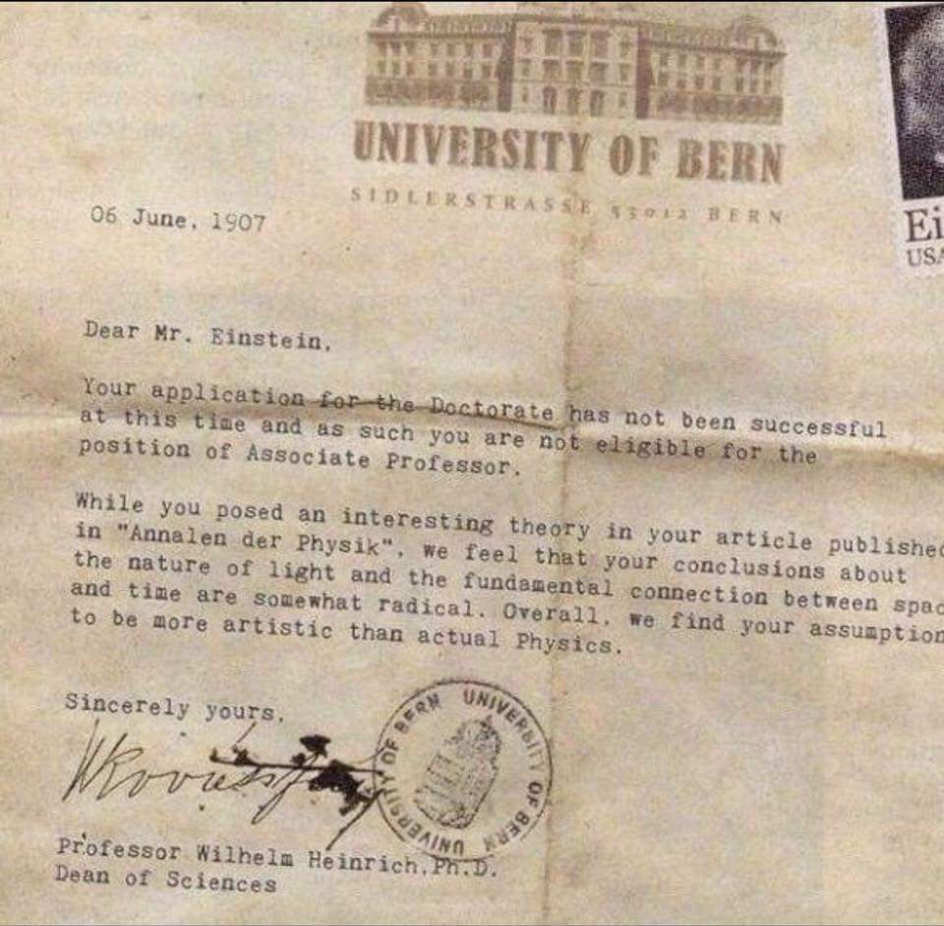

Figure 1: Figure description shall be written down the figure (non-italic)

  - Heading

Font size for the heading is 14. Use small letters and bold.

1.1.1 Sub-Heading

Font size for the sub-heading is 12. Use small letters and bold.

Table 1: Table description shall be on top of the table (non-italic)

 | Col1 | Col2 | Col2 | Col3
 | 1 | 6 | 87837 | 787
 | 2 | 7 | 78 | 5415
 | 3 | 545 | 778 | 7507
 | 4 | 545 | 18744 | 7560
 | 5 | 88 | 788 | 6344

Line1
Line2
Line3
Chapter 2
Line1
Existing Systems
Line1
Line2
Text of chapter 2 starts here ..

2

Line1
Line2
Line3
Chapter 3
Line1
Proposed System
Line1
Line2
Chapter 3 text goes here ..

Line1
Line2
Line3
Chapter 4
Line1
Evaluation and Results
Line1
Line2
Evaluation and Results gained goes in Chapter 4 and starts here ..

Line1
Line2
Line3
Chapter 5
Line1
Conclusion and Future Work
Line1
Line2
5.1 Conclusion

Conclusion shall be written here ..

5.2 Future Work

Future work starts here ..

Line1
Line2
Line3
References
Line1
Line2
References starts here and shall be written in IEEE format. Use proper format for the References as mentioned in Microsoft Word or Latex. The student is free to use any of these two editors and their References formats (IEEE).

References

1. | "Package Index," Developer, [Online]. Available: https://www.developer.android.com/reference/packages.html. [Accessed 28 June 2017].
2. | "Android," Wikipedia, [Online]. Available: http://www.wikipedia.com/child app. [Accessed 12 June 2017].

